Audiology Review Submission Changes Effective 11/1/2024

To begin submitting the review, go to the Member Hub, and under the Utilization Management Panel, click the ADD button.
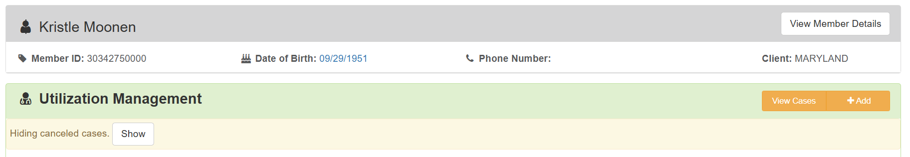
The Review Type is where the new changes take place.
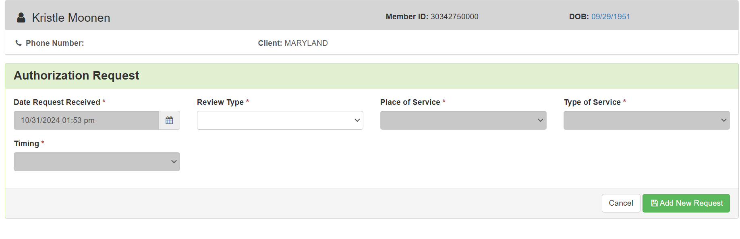
Click on the drop-down for the Review Type. Choose Audiology.
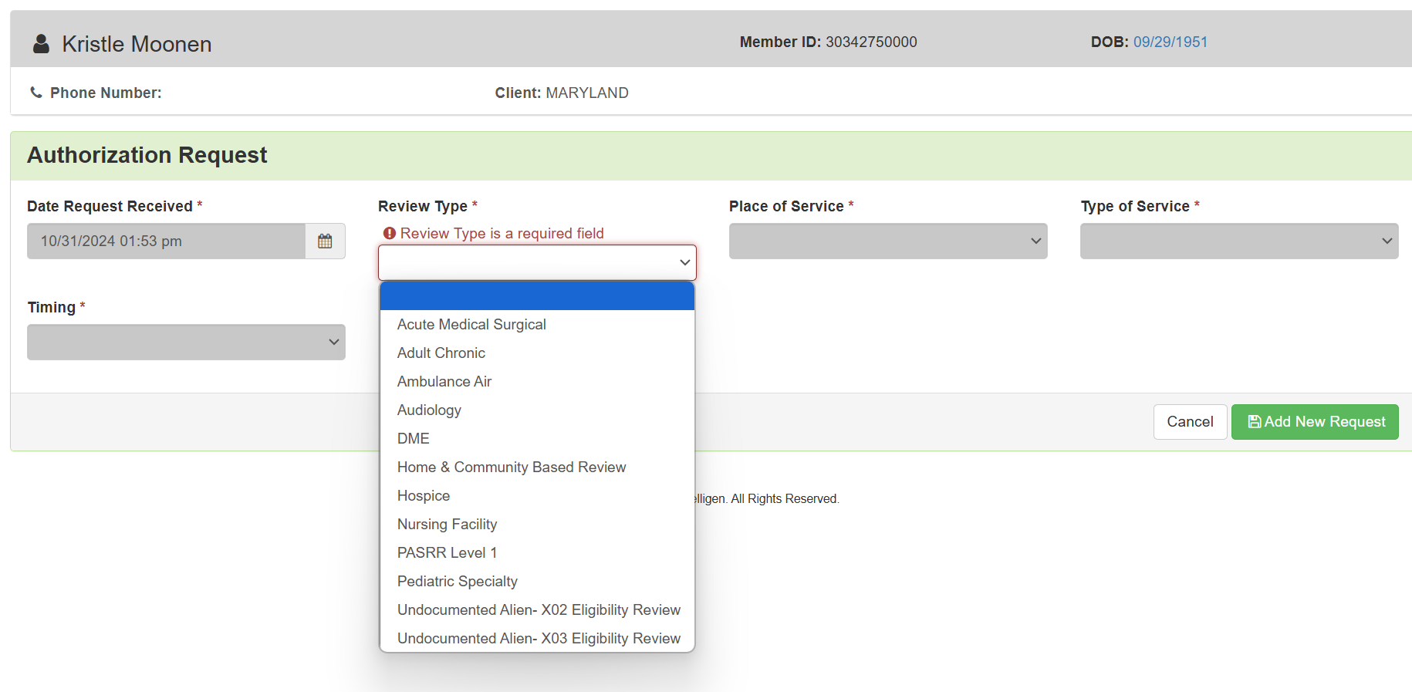
The remainder of the Authorization Request will be prepopulated with the following information.
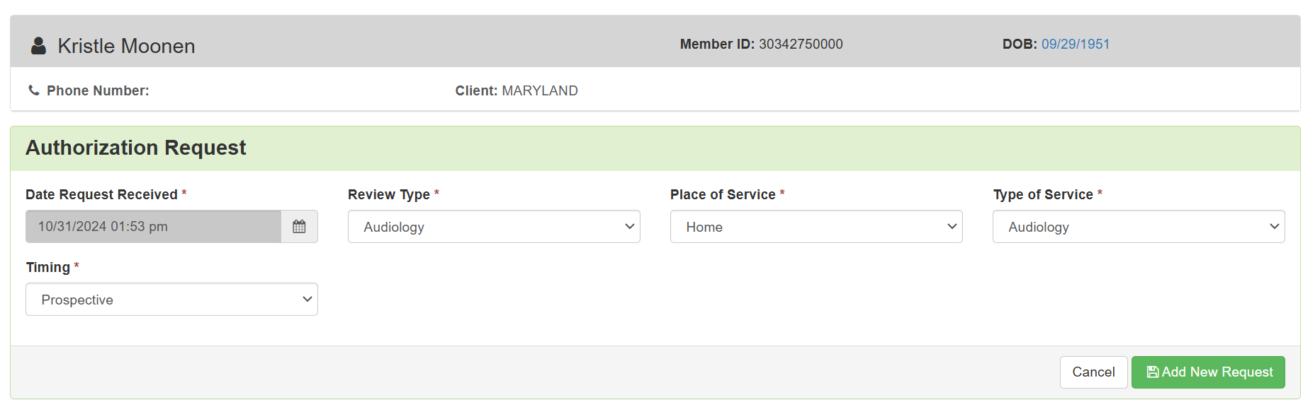
All other steps to submit the audiology review continue as listed in the audiology review process, which can be found at https://telligenmd.qualitrac.com/education-training/ under DME/DMS/PEN/Audiology, Audiology Reviews.

